|  |  |
| --- | --- |
| LMS Implementation project project charter  Month 2018 | CLIENT NAME  (ABBREVIATION) |

LMS IMPLEMENTATION PROJECT CHARTER

|  |  |
| --- | --- |
| Client Name: |  |
| Project Name: | Learning Management System Implementation |
| Project Manager: |  |
| Executive Sponsor: |  |
| Start Date: | Finish Date: |

Document Revision History

|  |  |  |  |
| --- | --- | --- | --- |
| **Version No.** | **Release Date** | **Author(s)** | **Description of Revision** |
| 1.0 | 1/9/2018 | Reni Bankole | LMS Implementation Project Charter V1.0 |
|  |  |  |  |
|  |  |  |  |

Table of Contents

1. PURPOSE OF PROJECT CHARTER 4

2. BUSINESS NEED 4

4. PROJECT SCOPE 4

5. ROLES AND RESPONSIBILITIES 5

5.1 Roles and Responsibilities – Yourmembership 5

4.2 Roles and Responsibilities - CLIENT NAME 5

6. PROJECT PLANNING 6

6.1 Major Deliverables / Milestones 6

6.2 TIMELINE 7

7. CRITICAL SUCCESS FACTORS 8

7.1 Assumptions 8

7.2 Constraints 8

8. KEY STAKEHOLDERS 8

9. RISK FACTORS 10

9.1 Change management 10

9.2 Management of project delivery issues 10

10.PROJECT CHARTER APPOVAL 11

# **PURPOSE OF PROJECT CHARTER**

The Project Charter formally authorizes Yourmembership Project Manager (PM) to develop and implement a new Learning Management System (LMS) for Client Name (abbreviation). The charter aligns stakeholders around the scope of the project and formally gains their commitment to fund and support the project. The intended audience of the project charter is the project sponsor and senior leadership.

# **BUSINESS NEED**

CLIENT NAME needs an LMS to serve their members in an engaging, personalized, and aesthetically pleasing experience that is relevant and user friendly. The design and versatility will need to be collaborative and will immerse the audience in the learning experience.

1. **PROJECT GOALS AND OBJECTIVES**

CLIENT NAME has a strategic goal to launch the LMS the first week of July 2018.

This will act as a soft launch of the LMS. The association will like the LMS to have the following features;

* Self-Assessment (SA) Tool – Baseline Features
* Integration with Personify and CME Repository
* Configuration and Branding – Phase 1
* Customizations (Phase 1)
* Content
* My Enrollments and Transcripts

# **PROJECT SCOPE**

The project will develop a professional learning portal that will enable CLIENT NAME to provide educational content, and tools to train, assess, and evaluate the performance of their learning communities.

The implementation process includes the following deliverables:

* Integration
  + SSO integration
  + Store (Catalog)
  + Entitlement
  + User Dashboard
* Branding/Configuration and Selection of Features and Modules
  + LMS Core Pages
  + SA Tool
  + Word Press Micro-Learning
* User Data Migration – As discussed at the X/XX/2018 kick-off meeting, user data migration is not needed for Phase 1 of the project. CME transcript will be in personify.
* Active enrolments in the legacy system will be brought over via the Holding Tank template.
* Business Rules: CE, Certificates
* Advanced Module Setup
  + Self-Assessment Tool
  + Word Press Micro-Learning Tool
* Assessment (Himalaya Tests) and Evaluations
* Training
* User Support
* Post Launch Excellence

# **ROLES AND RESPONSIBILITIES**

## **Roles and Responsibilities – Yourmembership**

|  |  |  |
| --- | --- | --- |
| **Name** | **Role** | **Responsibility** |
| Michele Windsor | Executive Sponsor | Project Oversight |
| John Sun | Chief Technology Officer | Technology Expert |
|  | Sr. Project Manager | Project Management |
| Chris Hills | Business Analyst | Business Requirements |
| Rob Luck | PMO | Project Resources Management |
| Reni Bankole | Sr. Project Manager | Process Lead |
| Louise Platiel | Instructional Design Manager | Content Development and Migration |

## **4.2 Roles and Responsibilities - CLIENT NAME**

| **Name** | **Role** | **Responsibility** |
| --- | --- | --- |
|  |  |  |
|  |  |  |
|  |  |  |
|  |  |  |
|  |  |  |
|  |  |  |
|  |  |  |
|  |  |  |
|  |  |  |
|  |  |  |
|  |  |  |
|  |  |  |
|  |  |  |
|  |  |  |
|  |  |  |

# **PROJECT PLANNING**

## **6.1 Major Deliverables / Milestones**

|  |  |  |  |
| --- | --- | --- | --- |
| **ID** | **Description** | **Requirement Due Date**  **(CLIENT NAME)** | **Implementation**  **Due Date**  **(YM)** |
| 1 | Goals, Strategic Objectives, and User Experience Definition |  |  |
| 2 | Selection and Configuration of Features and Modules |  |  |
| 3 | Integration and Data Exchange |  |  |
| 4 |  |  |  |
| 5 | Business Rules, CEU, Certificates, Roles and Permissions |  |  |
| 6 | Branding, Look and Feel of eLearning Portal |  |  |
| 7 | Content Creation / Import - Assessment & Evaluations, Word Press Micro Learning |  |  |
| 8 | Training and User Support – Admin #1 |  |  |
| 9 | Staging Readiness |  |  |
| 10 | Admin Training Session 2 |  |  |
| 11 | Pre-Production |  |  |
| 12 | Production Creation |  |  |
| 13 | Production Launch Readiness |  |  |
| 14 | Production Launch MVP Ready |  |  |
| 15 | Client Go-live |  |  |
| 16 | Program Experience – 30Days Check after Go Live |  |  |

## **6.2 TIMELINE**

The LMS Implementation process follows a 16-week process as outlined below: Replace Graphic

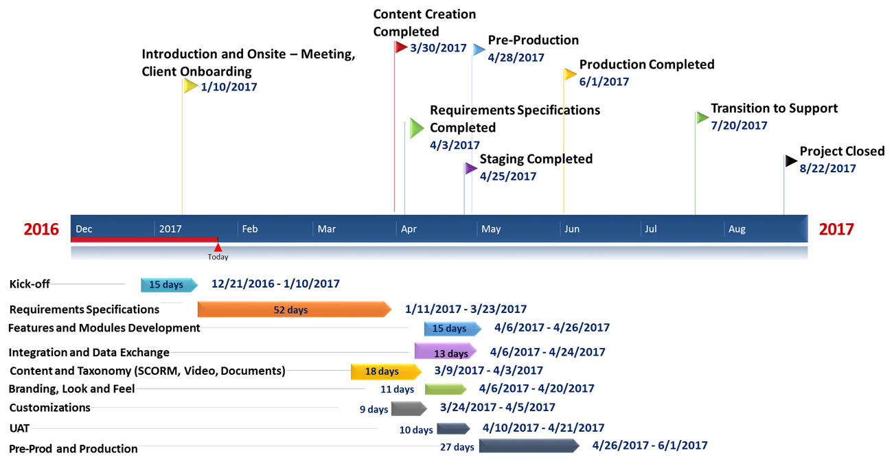

# **CRITICAL SUCCESS FACTORS**

## **7.1 Assumptions**

* CLIENT NAME will provide Information Technology and Integration resources
* CLIENT NAME will grant Yourmembership access to current learning programs with adequate login authorizations
* Key Stakeholders will comply with guidelines in the Communication Plan
* CLIENT NAME will provide product specifications and customization information during Requirements Gathering workshop
* CLIENT NAME will provide source materials for content to be migrated to the proposed platform
* CLIENT NAME will provide design and branding guideline
* CLIENT NAME will test products in staging environment when required
* CLIENT NAME resources will attend administrator training as specified in the project management plan
* CLIENT NAME project manager will maintain regular communication with Yourmembership project manager

## **7.2 Constraints**

* Fixed project duration of 16 weeks
* Project will be executed within the agreed scope and budget
* Availability of adequate content provided by CLIENT NAME for inital product launch
* Availability of CLIENT NAME resources for System Integration and IT guidance

# **KEY STAKEHOLDERS**

| **Name** | **Role** | **Company** | **Contact Information** |
| --- | --- | --- | --- |
| Tamer Ali | SVP and GM Education | YM | [tali@yourmembership.com](mailto:tali@yourmembership.com)  630.282.6401 ext.7001 |
| Michele Windsor | VP of Operations | YM | [mwindsor@yourmembership.com](mailto:mwindsor@yourmembership.com)  630.282.6401 ext. 7017 |
| Reni Bankole | Sr. Project Manager/Process Lead | YM | rbankole@yourmembership.com |
| Chris Hills | Business Analyst | YM | chills@yourmembership.com |
|  | Sr. Project Manager | YM | jdesimone@yourmembership.com |
| John Sun | CTO | YM | jsun@yourmembership.com |
| Marc Derison | Business Development Manager | YM | mderison@yourmembership.com |
| Nayela Hoda | Project Manager, Content | YM | nhoda@yourmembership.com |
| Louise Platiel | Instructional Designer, Content | YM | lplatiel@yourmembership.com |
| Tina Turner | VP Organizational Learning and Development | YM | [tturner@yourmembership.com](mailto:tturner@yourmembership.com) |
|  |  |  |  |
|  |  | CLIENT NAME |  |
|  |  | CLIENT NAME |  |
|  |  |  |  |
|  |  |  |  |
|  |  |  |  |
|  |  |  |  |
|  |  |  |  |
|  |  |  |  |
|  |  |  |  |
|  |  |  |  |
|  |  |  |  |
|  |  |  |  |
|  |  |  |  |
|  |  |  |  |
|  |  |  |  |

# **RISK FACTORS**

## 9.1 Change management

During the course of the project, issues or events may occur that results in a need to amend the scope or objectives. Changes to the scope or objectives will need to follow a change control approval process before being reflected in the project plan.

## 9.2 Management of project delivery issues

A project delivery issue is anything which if left unresolved, could delay or have a negative impact on the success of the project. Issues can arise in one or more of the following areas: budget, schedule, resources, or quality of work. Yourmmebership will endeavour to resolve any unknown issue with utmost professionalism.

* + 1. Requirements Defining User-Flow and Business Rules – (Scope)

Defining the user-flow and business rules for your members and nonmembers is a key success and risk factor. If the project teams are not defining and documenting the user flow and business rules in a timely manner this causing delays in project timing and often leads to scope creep.

9.4 Content

High volume of content to be migrated, while also determining which content to remove and which to enhance. Two decision streams, require quick decisions by CLIENT NAME to avoid content /overall launch delays

# **10.PROJECT CHARTER APPOVAL**

The undersigned acknowledge they have reviewed the Project Charter**,** authorize, and fund the LMS Implementationproject. Changes to this Charter will be coordinated with, and approved by the undersigned or their designated representatives.

|  |  |  |  |
| --- | --- | --- | --- |
| Signature: |  | Date: |  |
| Print Name |  |  |  |
| Title: |  |  |  |
|  |  |  |  |
| Signature: |  | Date: |  |
| Print Name: |  |  |  |
| Title: |  |  |  |
|  |  |  |  |
| Signature: |  | Date: |  |
| Print Name: |  |  |  |
| Title: |  |  |  |
|  |  |  |  |
| Signature: |  | Date: |  |
| Print Name: |  |  |  |
| Title: |  |  |  |
|  |  |  |  |